Machrihanish Bird Observatory
Founded September 1993 (26th Year)
June Report 2020

Compiled by: Eddie Maguire (Chief Warden)

CLOSED to VISITORS until Further Notice
For Updates / Enquiries...
Contact the Observatory
Mobile - 07895 952640
E-mail – msbowarden@gmail.com
Website – machrihanishbirdobservatory.org.uk

MSBO Aphorism...
‘Time spent in reconnaissance is seldom wasted ’

MSBO Photo of the Month...
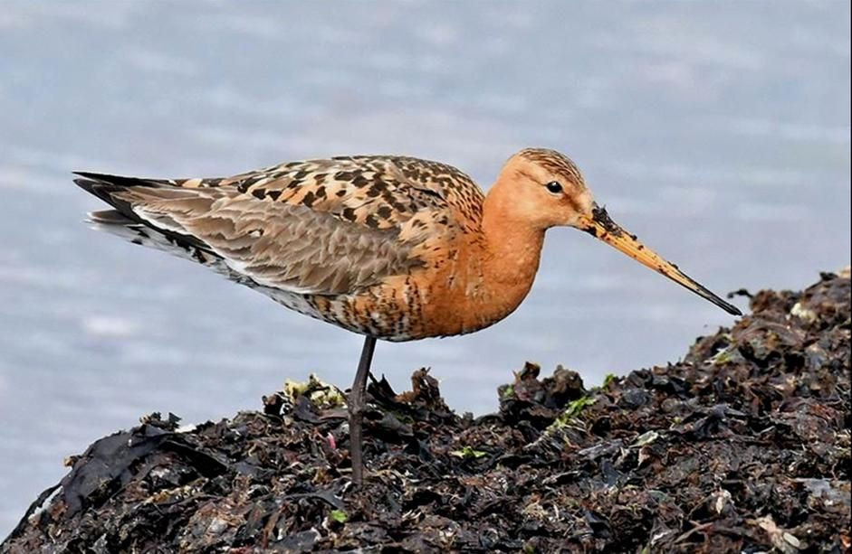
Icelandic Black-tailed Godwit – adult / early returning migrant MSBO 27th June

MSBO photos this month were taken by the Warden
List of Selected Species for June

Greater Canada Goose
Breeding; b/4 at Brucefield (c. 1 mile north of Peninver) on 2nd (John Maguire pers. comm.).

Common Shelduck
Breeding by MSBO; b/3 just hatched on 7th, b/6 on 11th (Dave Haggerty pers. comm.), b/4 just hatched on 15th and b/1 on 27th.

Table 1. Shelduck productivity at Machrihanish during May / June 2016 – 2020.
Year | No. broods | No. ducklings | Mean brood size
2020 | 4 | 22 | 5.5
2019 | 3 | 19 | 6.3
2018 | 6 | 30 | 6
2017 | 8 | 55 | 6.7
2016 | 6 | 37 | 6.1

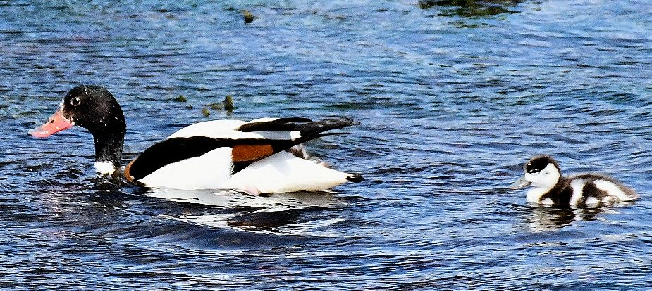
Shelduck – female with duckling 11th June

Mallard
Breeding by MSBO; b/1 on 9th.

Greater Scaup
Four >S on 28th.
A rare June record.
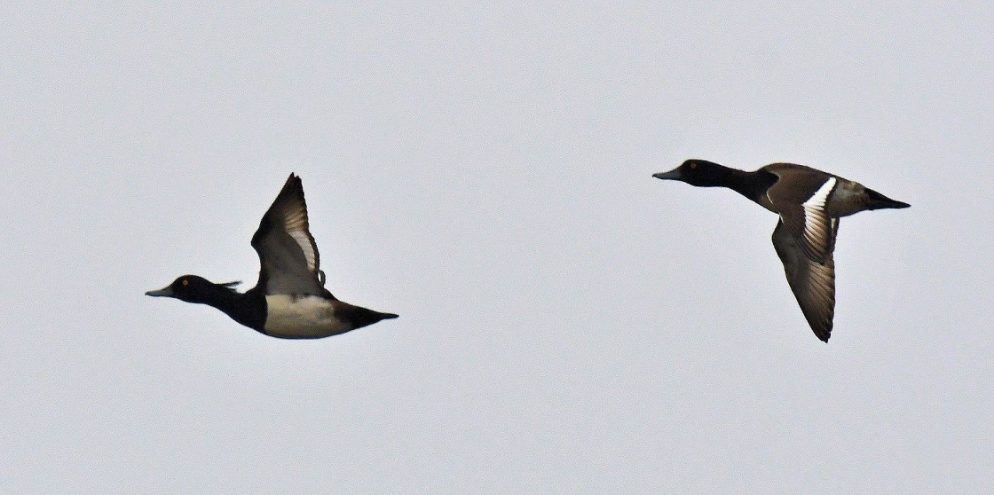
Greater Scaup – fly-by’s off MSBO 28th

Common Scoter
Flock 28 >S on 11th.
Although distant, the tight group appeared to be predominantly males.
This species is a regular June passage visitor in variable numbers and flocks usually consist mainly of males.

Common Eider
Breeding by MSBO; b/4 (just hatched) on 3rd, b/1 and b/5 (both just hatched) on 7th.
Eclipse period; last males seen in flight were 2 on 9th and one on 11th. Females; 2 >S on 25th and one >S on 28th (moult in females is around a month later than males).
Southend; b/1 Keil Point on 6th.

Table 2

Common Eider productivity at Machrihanish May / June 2016 – 2020.

Year | No. broods | No. ducklings | Mean brood size
2020 | 6 | 19 | 3.1
2019 | 6 | 18 | 3
2018 | 8 | 25 | 3.1
2017 | 6 | 23 | 3.8
2016 | 10 | 35 | 3.5

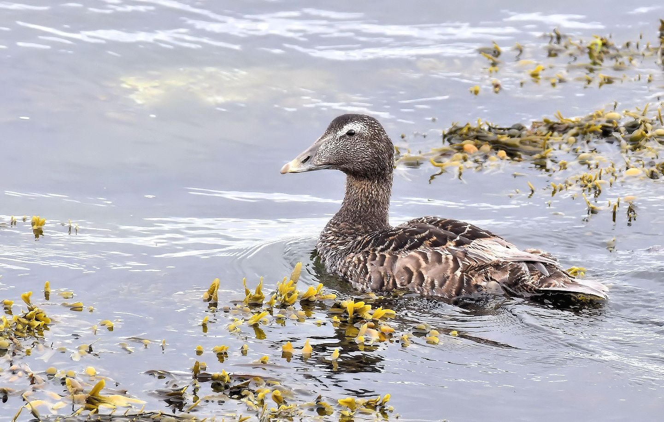
Common Eider – MSBO 22nd June

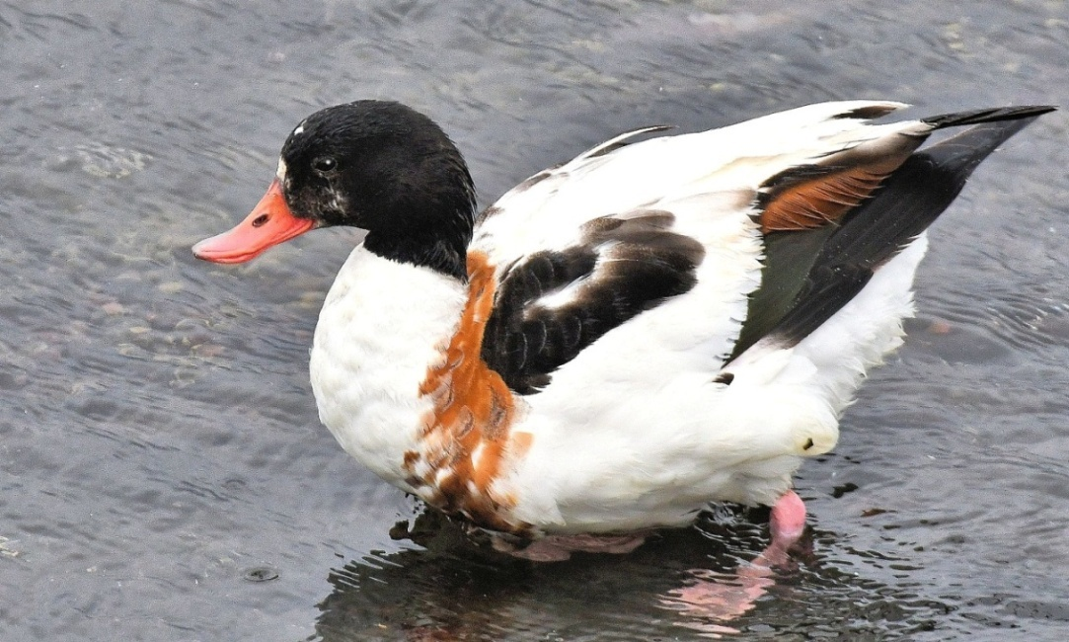
Shelduck – female 21st June
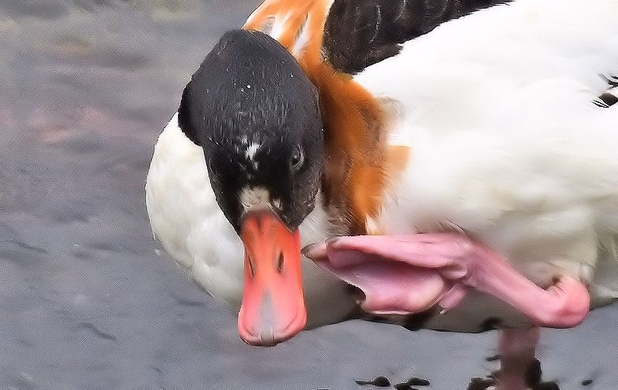
Shelduck – female 21st June

Great Cormorant
Mouth of Campbeltown Loch (south bank); 10 Kildalloig Bay on 4th (David / Jo).

European Shag
Mouth of Campbeltown Loch (south bank); 90 Kildalloig Bay on 4th (David / Jo).
MSBO; 62 at regular loafing sites on 9th.

Northern Gannet
MSBO Northern Gannet Overland Project (Coordinator / Charlie Robertson).
Surveillance of Northern Gannets crossing 8km overland to the west from Campbeltown Harbour to Machrihanish Bay was maintained this month.

Table 3.
Date / number of adult Gannets crossing 8km overland to the west from Clyde waters (Campbeltown harbour) to the Atlantic (Machrihanish Bay) during June 2020 along with wind direction and departure times of first / last bird.

June  Date | Number  Adults  Departing  Overland >W | Wind  Direction  &  force | Campbeltown  Departure  times of first / last  bird >W
1st | 6 | S 1-2 | 13:16—20:52
2nd | 16 | W 1-2 | 14:24—18:50
3rd | 2 | N 2-3 | 11:29—17:43
4th | 26 | NNW 3-4 | 09:30—21:12
5th | 15 | NNW 5 | 10:17—21:40
6th | 10 | N 3 | 09:16—20:55
7th | 10 | N 1-2 | 13:22—21:12
8th | 5 | SW 2 | 11:09—18:10
9th | 4 | W 1 | 15:29—21:40
10th | 3 | E 1-3 | 15:34—17:39
11th | 14 | NE 4 / calm | 10:58—21:50
12th | 17 | NE 2 / calm | 13:17—19:35
13th | 17 | NE 2 | 15:36—20:50
14th | 1 | N 2 / W 1-2 | 16:04
15th | 3 | Calm | 13:03—21:00
16th | 0 | SW 1 / calm | -
17th | 2 | W 1 | 10:33—16:43
18th | 1 | Calm | 11:31
19th | 5 | SW 1-2 | 13:15—15:43
20th | 3 | ESE 5 | 8:19—18:22
21st | 6 | SW 4 / calm | 07:20—19:25
22nd | 2 | SE 5-6 | 09:20—12:06
23rd | 2 | SE 1-2 | 16:06
24th | 11 | Calm | 11:45—21:20
25th | 8 | Calm | 12:40—21:44
26th | 13 | E 3-4 | 17:45—20:02
27th | 11 | SE 3 | 20:06—21:32
28th | 2 | W 4-5 | 14:51—16:45
29th | 22 | WNW 5 | 12:32—21:25
30th | 2 | Calm | 14:57—17:25
Total | 239 |  | 2020  March – June Total  1,340

A very poor showing after the recent May record monthly total of 1,045.
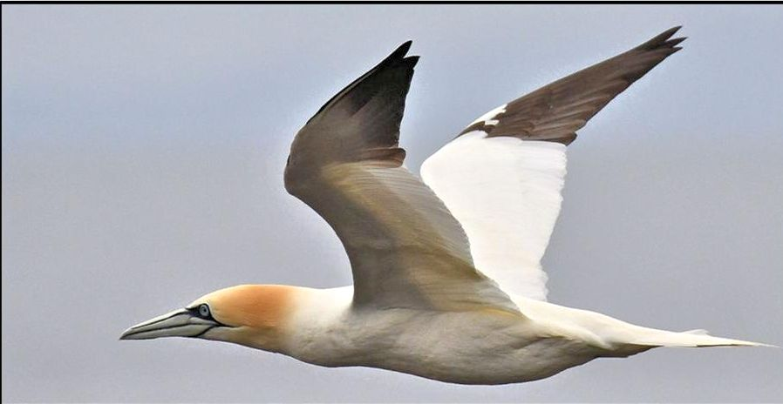
Northern Gannet - off MSBO 5th June

Eurasian Oystercatcher
Breeding; clutch hatched 20m from MSBO on 3rd. Another pair laid first egg 2m from viewing platform (full clutch on 6th / eggs predated 20th / 21st).
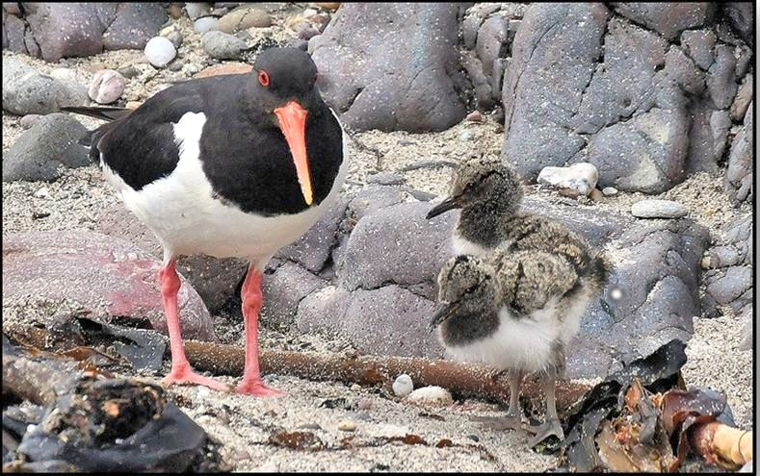
Oystercatcher – with chicks MSBO 6th June

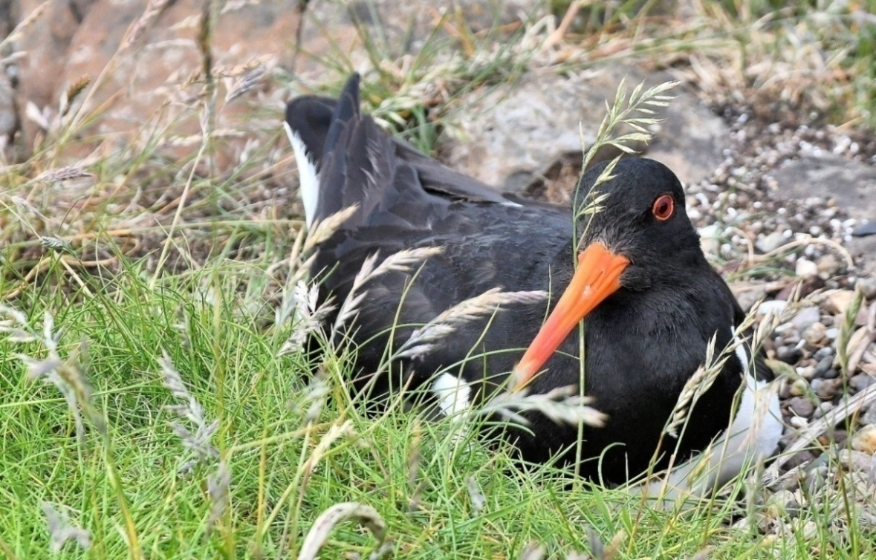
Oystercatcher – incubating 8th June

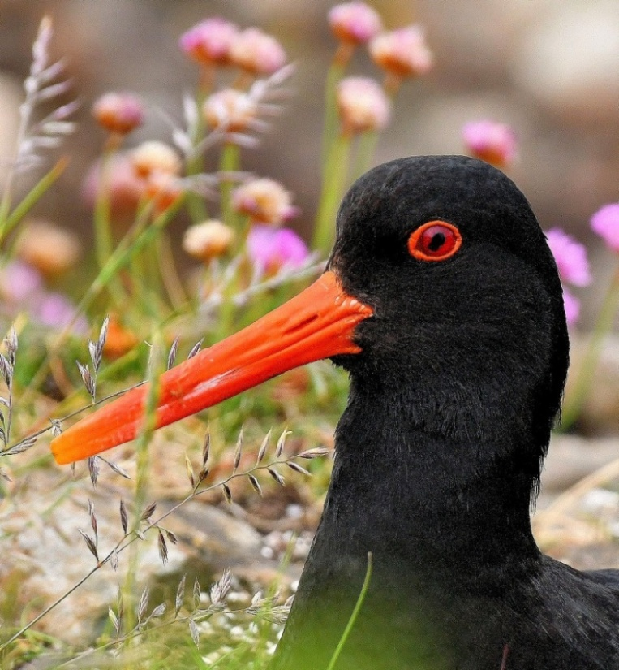.
Oystercatcher – on nest MSBO 4th June

Common Ringed Plover
Breeding; a pair with b/3 on 9th.
Unusual nest site with full clutch on 12th was on rock 2m above the shore.
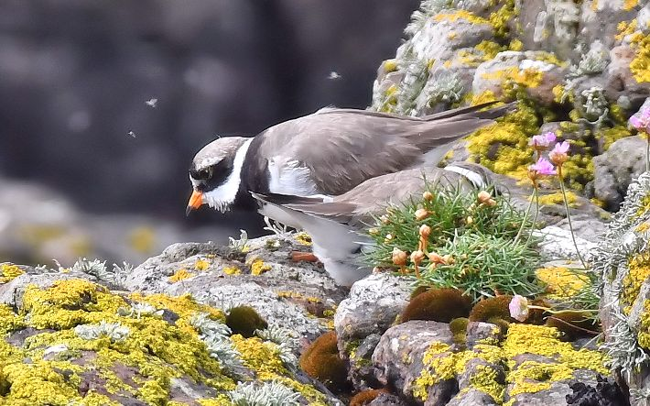
Ringed Plover – change-over duty at unusual choice of nest site 21st June
Normally eggs are laid on sand / shingle

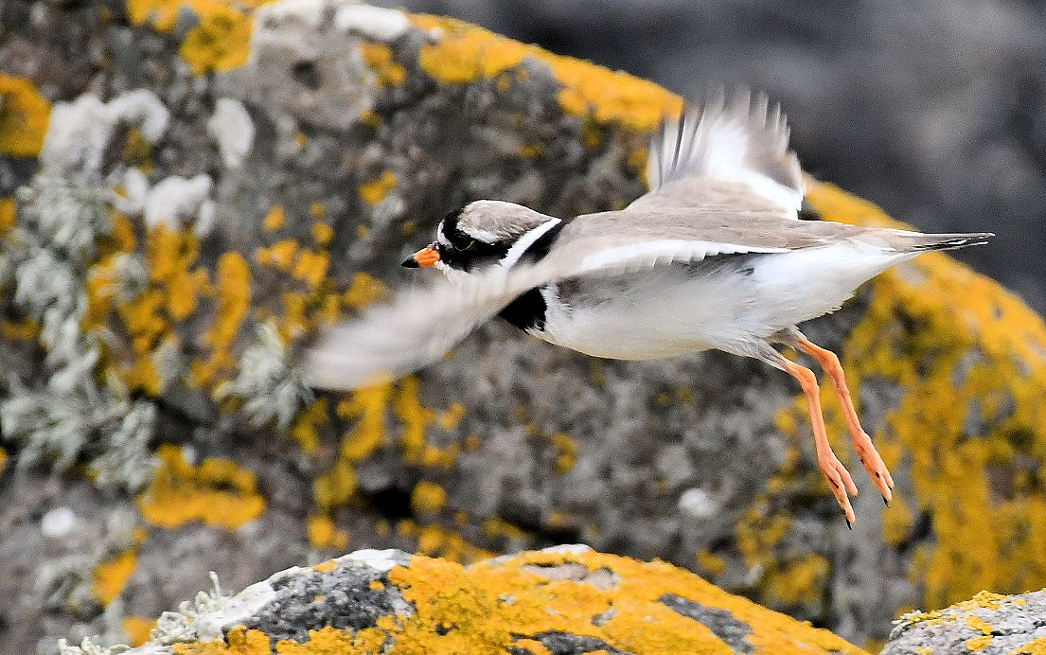
Ringed Plover – male approaching nest site 9th June

Northern Lapwing
Flock 10 in-off-sea on 25th.

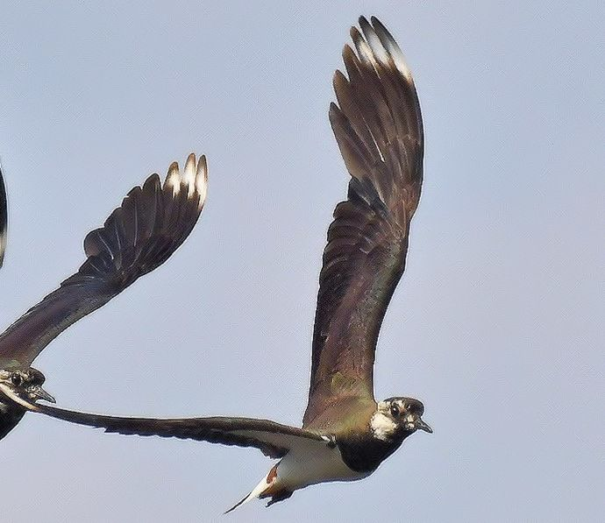
Lapwings – incoming at MSBO 25th June

Dunlin
Eleven in breeding plumage arrived with Sanderlings on 1st.

Sanderling
A flock of 40 migrants arrived on 1st and were present for several hours.

Common Sandpiper
Breeding; pair bred (b/3) by MSBO.
Three >S offshore on 26th and one >S on 29th.
This migrant wader leaves early with peak passage numbers occurring in July.

Common Redshank
The first juveniles arrived on the shore on 29th.

Common Greenshank
The first returning bird was an adult on 28th.
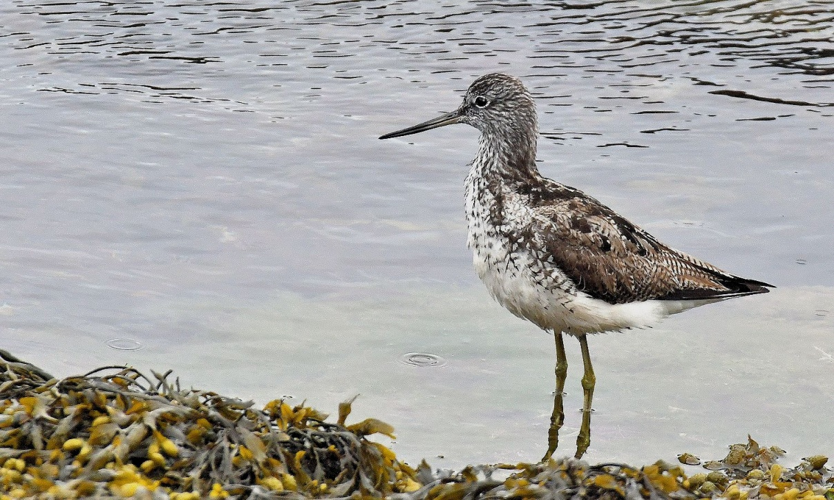
Greenshank – adult 28th June
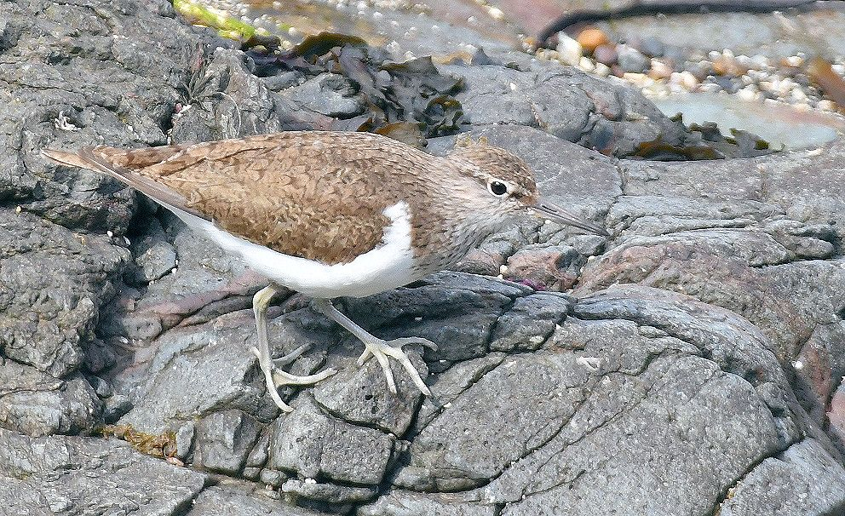
Common Sandpiper – one of a breeding pair by MSBO 26th June

Green Sandpiper
A surprisingly early fly-by >S – calling – on 28th.

Whimbrel
One >N on 15th and one on the shore on 29th.
Appearances in June occur most years.
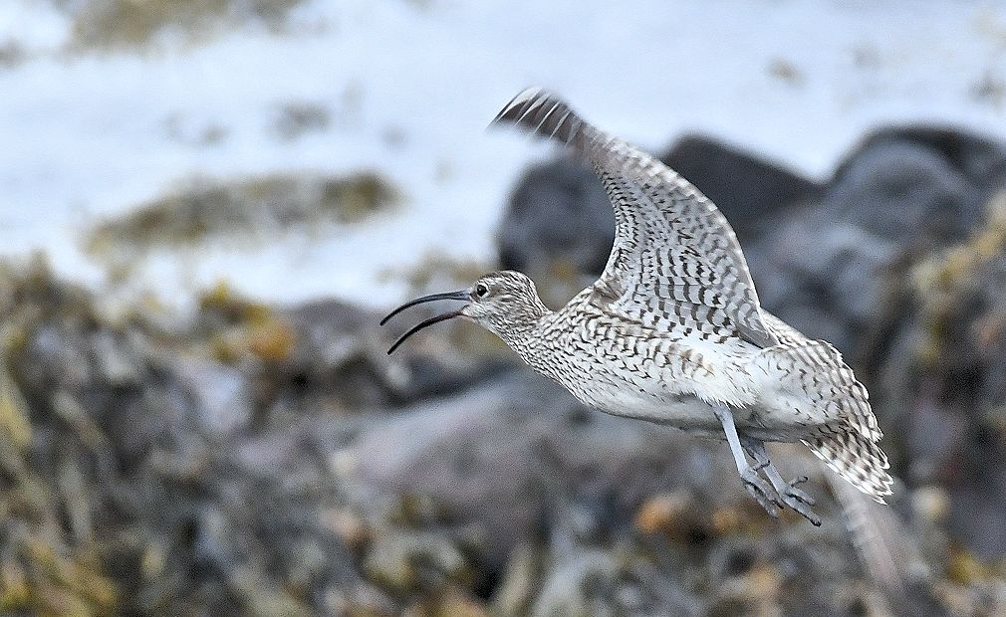
Whimbrel – 29th June
.
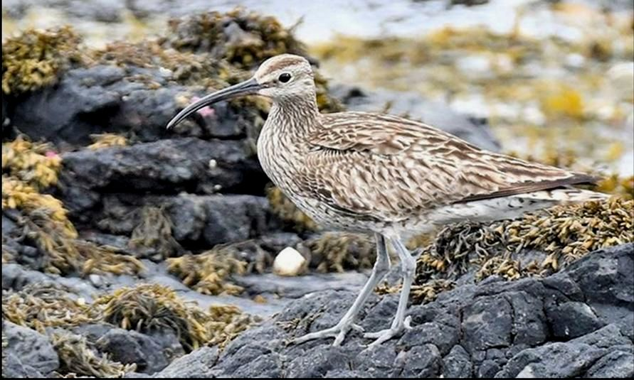
Whimbrel – 29th June
Eurasian Curlew
MSBO; the regular mid-summer southerly passage of fresh juveniles was underway with small numbers (ones and twos) from 12th (exodus of Scottish-bred birds?).
The best visible migration noted was 27 (2 flocks) on 19th, 39 (2 flocks) on 21st, 12 on 23rd, 7 on 25th, 16 on 28th.
Campbeltown; a flock of 18 >W - high over the town - on 22nd and 2 >W on 24th (Charlie Robertson pers. comm.).

Black-tailed Godwit
Early returning adults included one at Campbeltown Loch on 26th (Brian Morton / Family pers. comm.), 3 adults at MSBO on 27th and a single there on 28th.

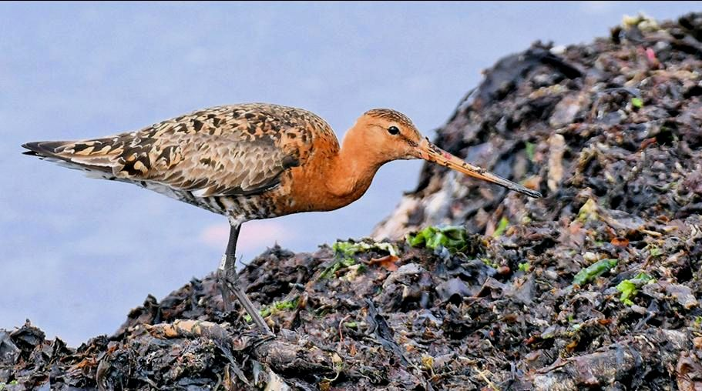
Black-tailed Godwit – adult MSBO 27th June
Note ring on left leg above knee

Great Skua
One >S well offshore at 14:40hrs on 30th.

Mediterranean Gull
A first-summer (2CY) fly-by was photographed >S at 11:45hrs on 28th – the first record this year.
There were two records in Mid Argyll; a colour ringed first-summer was at the Add Estuary on 22nd June (Jim Dickson pers. comm.) and an adult was there on 29th (David Jardine pers. comm.).
These are rare June records for this increasing visitor to Argyll. The first record for Argyll was an adult at Campbeltown July - September 1975 – the 5th Scottish record (pers .obs.).
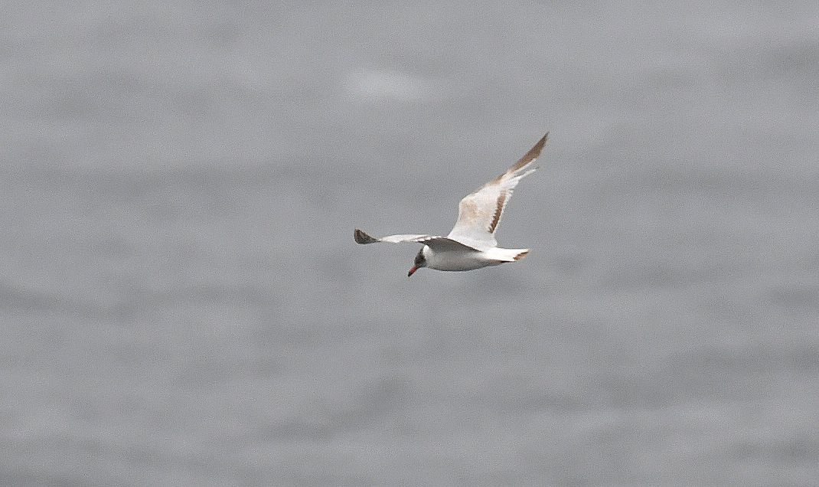
Mediterranean Gull – a fly-by 2CY >S MSBO 28th June

Sandwich Tern
Around a dozen were present on 3rd / coition was noted.
Counts later; 10 on 21st, 7 on 23rd, a good summer count of 19 on 25th and 8 on 27th.
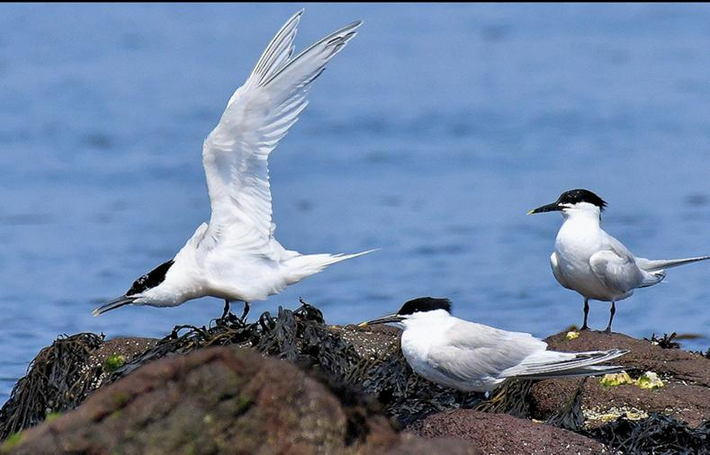
Sandwich Terns – MSBO / a good presence on 25th June
Arctic Tern
Breeding; at least 8 birds present at Big Scone Island colony off the village on 3rd / coition was noted.

Common Guillemot / Razorbill
Small numbers of both species >S carrying sand-eels from 13th.

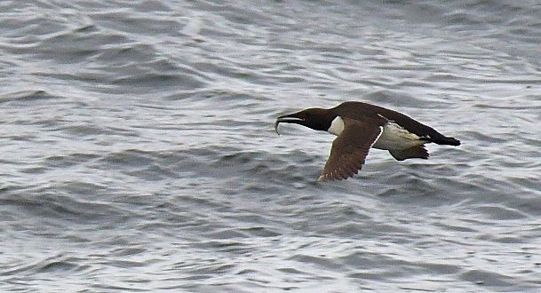
Guillemot – on the way (>S) to a colony carrying a sand-eel
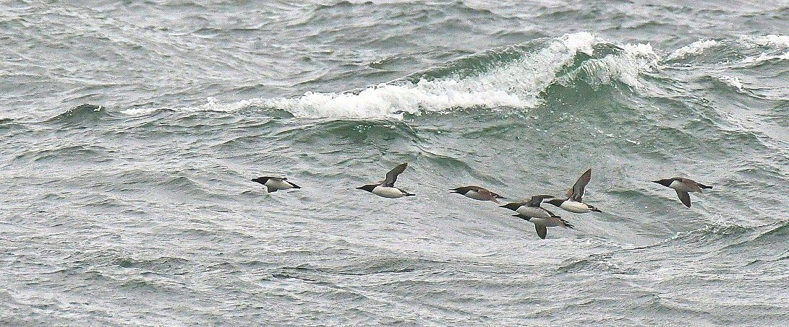
Razorbill (front bird) and Guillemots – off MSBO in a near-gale 29th June

Long-eared Owl
Breeding; begging calls of fledgling(s) heard at Lephinstrath, near Southend on 23rd (per Jim Dickson).
There is an isolated small conifer plantation nearby at Lailt.
Almost certainly an under-recorded species.

Common Swift
Breeding; in Campbeltown, one pair bred at 125 Longrow (by the Coop). Nest site was under roan of the building turret (external part of building that houses stairs to flats). Two other pairs highly likely breeding at High St were in similar turret buildings. Also, 2+ pairs likely breeding at the old tenement on Saddell St (by Tesco Metro).
The max count of many screaming parties seen over the town was 14 on 5th.

Great Spotted Woodpecker
Campbeltown; one visited a bird table at Kilkerran Glebe on 25th - first record for this location (Iona Smart pers. comm.).
Although a relatively common breeding species in most suitable habitats in Kintyre (especially the policies) they are scarce in town, being noted mainly in winter and usually at bird tables.

Rock Pipit
Breeding; b/4 fledged from flower box in MSBO garden on 2nd.
The courtship ‘stalking dance’ was noted on 15th.

Eurasian Magpie
Peninver; 2 on 4th (Johnny Robertson pers. comm.) and three separate sighting of a single bird on 29th (Ileane Craig pers. comm.).
Machrihanish; 3 birds Lossit Estate 28th May – 29th June (George Sharp / Charlie M^{c}Millan et al pers. comm.). This brings the total number of multiple occurrences at locations in Kintyre during March - June to 6 involving a total of 14 birds.
Stewarton; one regular all month (Davie Reid / Errol Crutchfield / Agnes Stewart pers. comm.).
Campbeltown; 2 regular early in the month and singles were seen briefly on 15th and 21st (Charlie Robertson et al). Both these birds were regular at Lorne Campbell Court (Elizabeth Campbell per Iona Smart).
Carradale; one on 1st (Jim Dickson pers. comm.).

Eurasian Jay
Machrihanish; one Lossit Estate old woodland on 11th (George Sharp pers. comm.).

Common Starling
Numbers of juveniles on the shore feeding on kelp fly larvae increased as the month progressed. Counts included 20 on 13th, 35 on 18th, 50+ on 21^{s} and 65 on 28th.
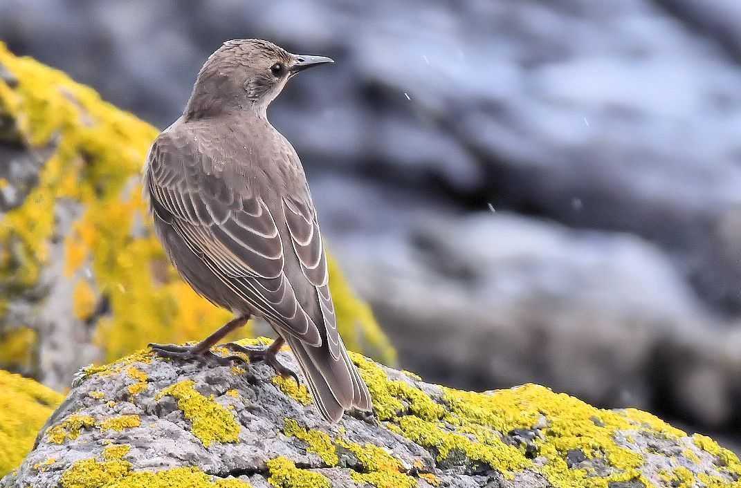

Starling – juvenile MSBO 21st June

Pied Flycatcher
Southend; a male near Lephinstrath Bridge 1st and 4th (per Jim Dickson).

European Stonechat
South-east Kintyre; b/3 at Corphin Bridge on 4th (2 males present; David Millward / Jo Goudie pers. comm.).

Northern Wheatear
Breeding; 3 pairs bred between MSBO and the village.

European Greenfinch
Regular at MSBO feeding station with max count 10 on 5th including several juveniles.

European Goldfinch
Regular at MSBO feeding station with max count 16 including 7 juveniles on 5th.
A pair arrived at the station on 7th with b/5 in tow.

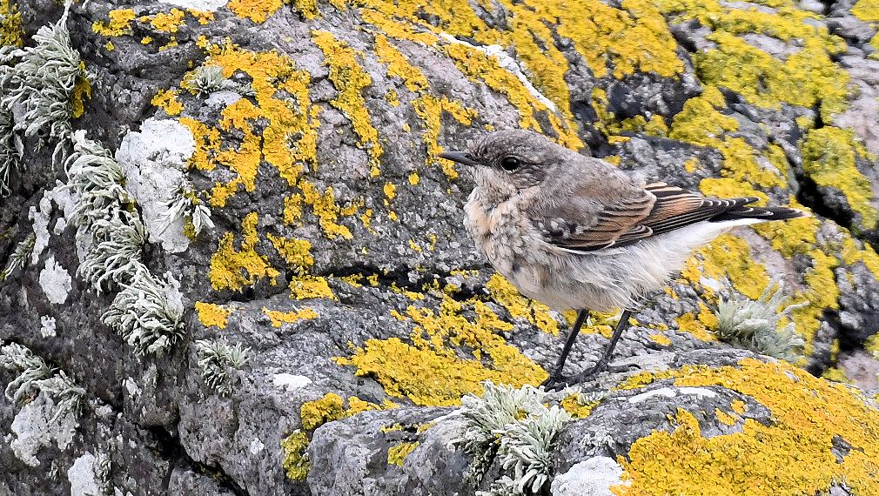
Wheatear – juvenile 28th June

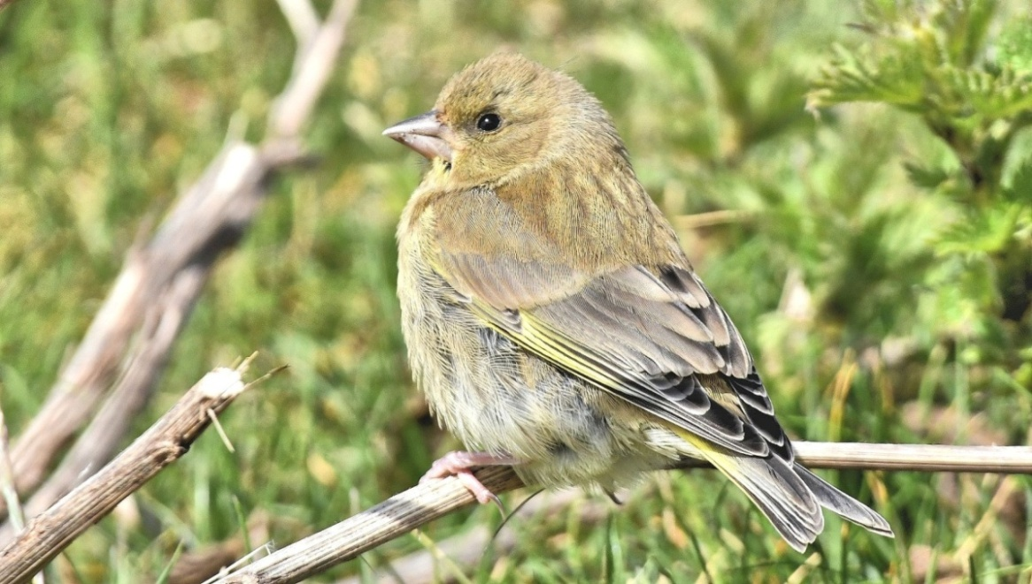
Greenfinch – juvenile 5th June
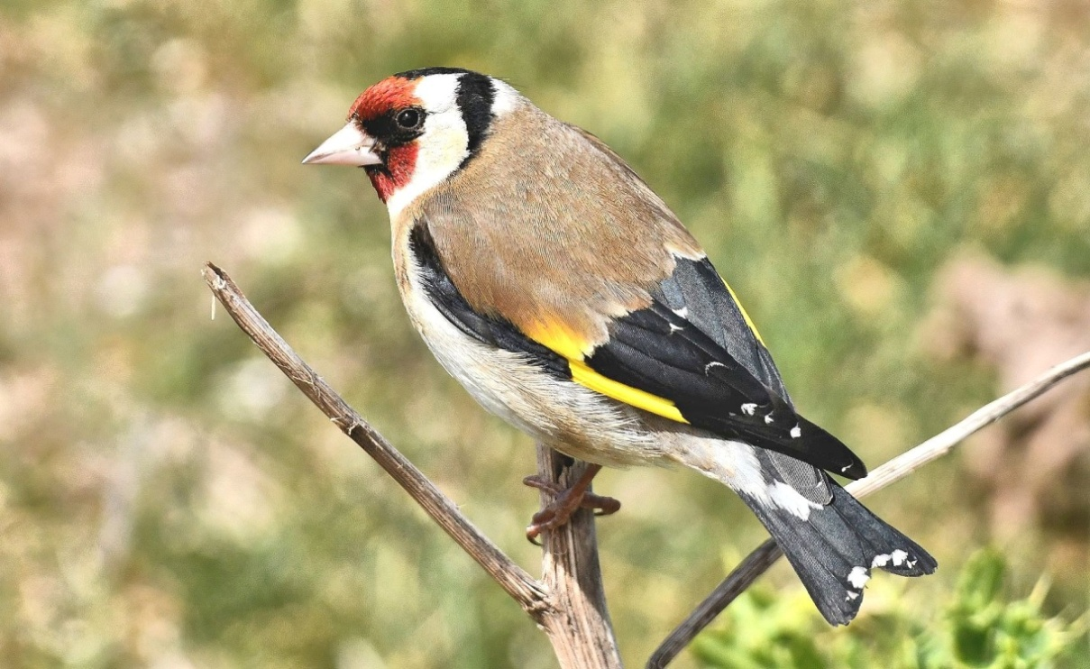
Goldfinch – MSBO 5th June
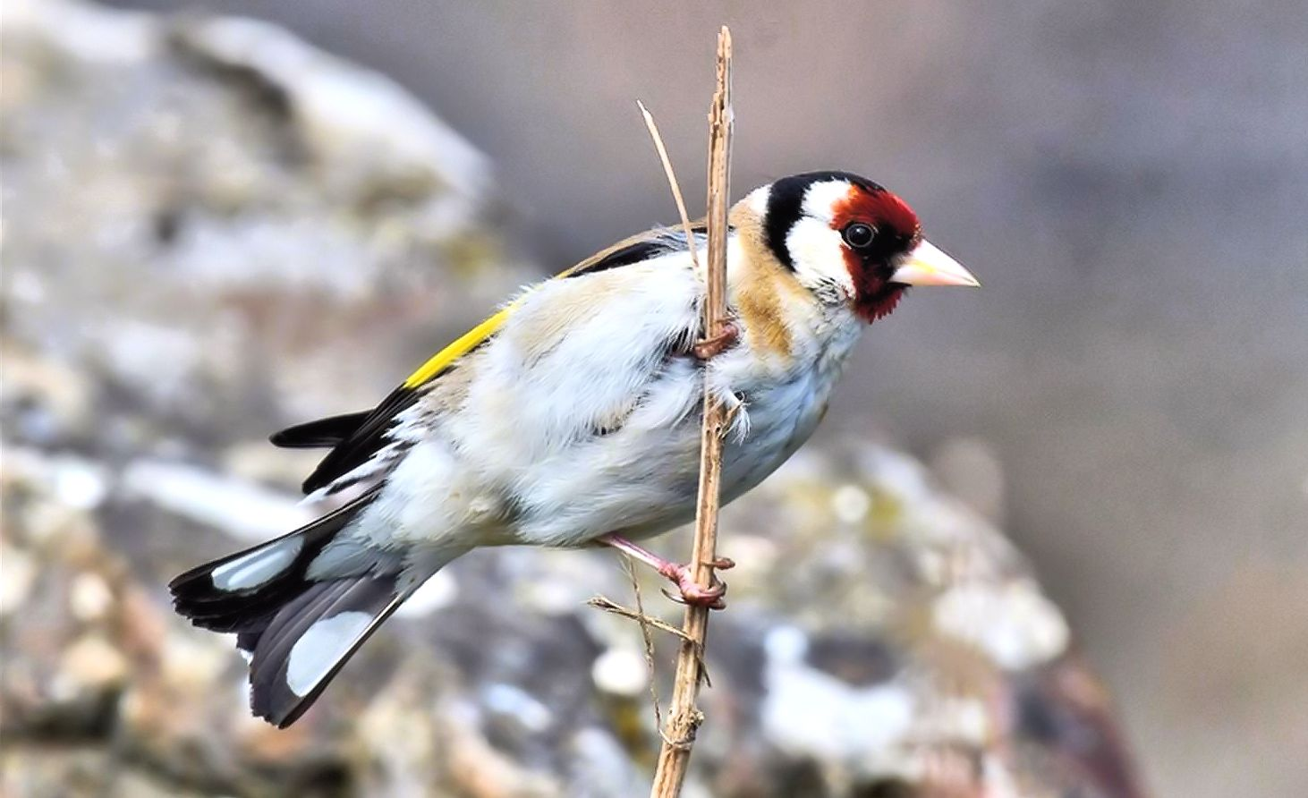
Goldfinch – MSBO 11th June

Machrihanish Airbase

June Records

Records from Airbase by MSBO Wardens
David Millward / Jo Goudie and Eddie Maguire

MACC Photo of the Month...
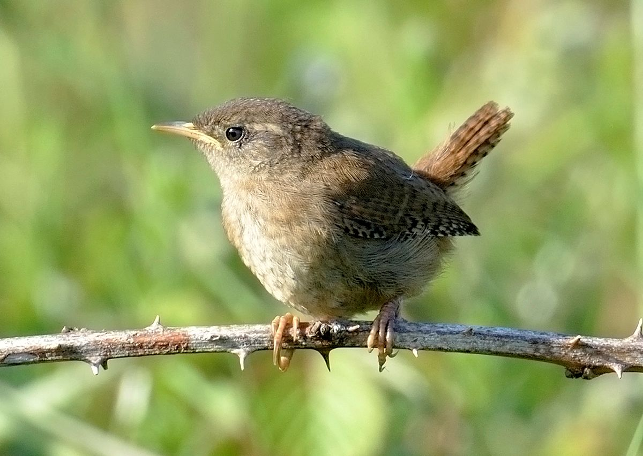
Wren – fledgling 24th June / Photo Jo
List of Selected Species

Common Buzzard
Breeding: nest on gutter of unused building (b/1 at same nest site 2019).
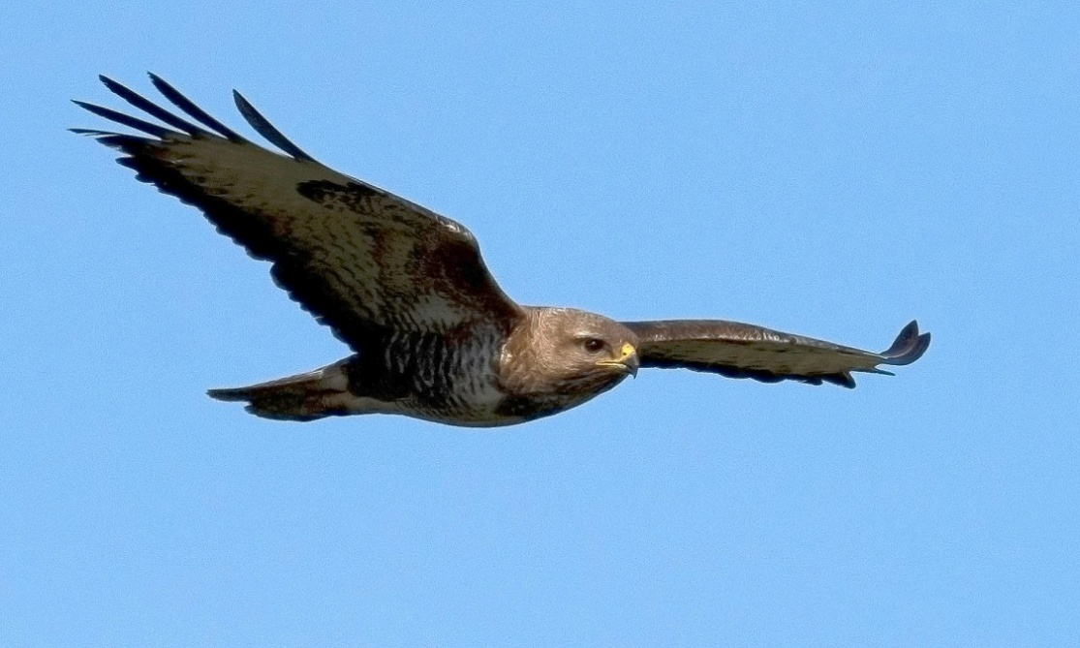
Buzzard – 1st June / Photo Jo

European Stonechat
Further territories were found this month bringing the total number of breeding pairs to 6.

Common Whitethroat
Many fledglings seen throughout the month.

Sedge Warbler
Many fledglings seen throughout the month.

Meadow Pipit
Many juveniles seen on throughout the month.

European Greenfinch
Many juveniles seen during the monrth.

Lesser Redpoll
At least 10 on 1st, 8 on 14th and 20+ on 17th. Many juveniles noted.

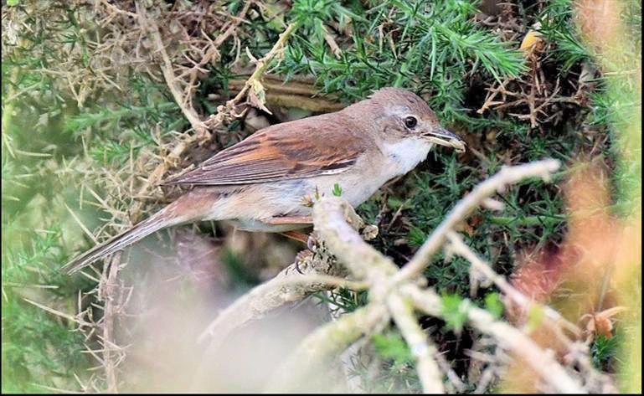
Common Whitethroat – 12th June / Photo Eddie

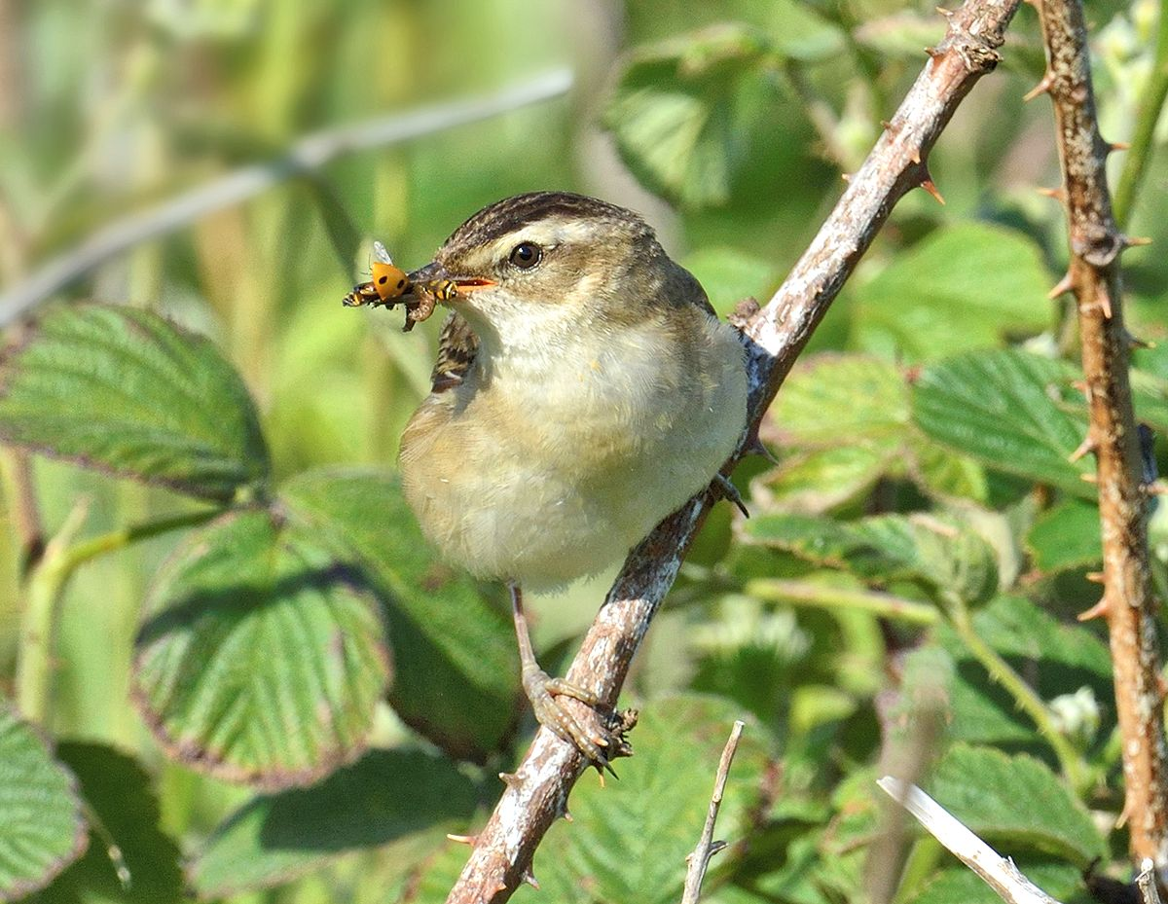
Sedge Warbler – 23rd June / Photo Jo

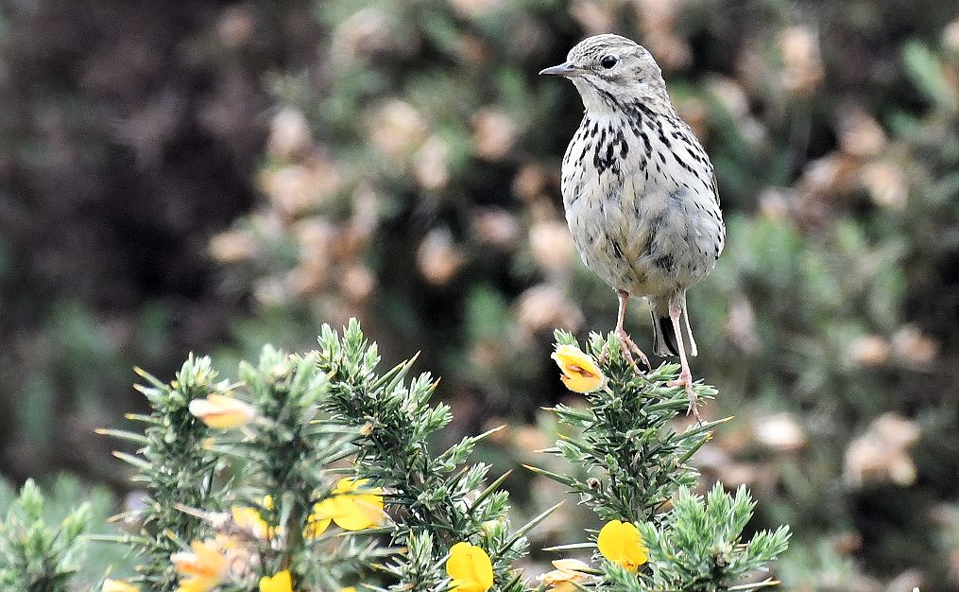
Meadow Pipit – 12th June / Photo Eddie
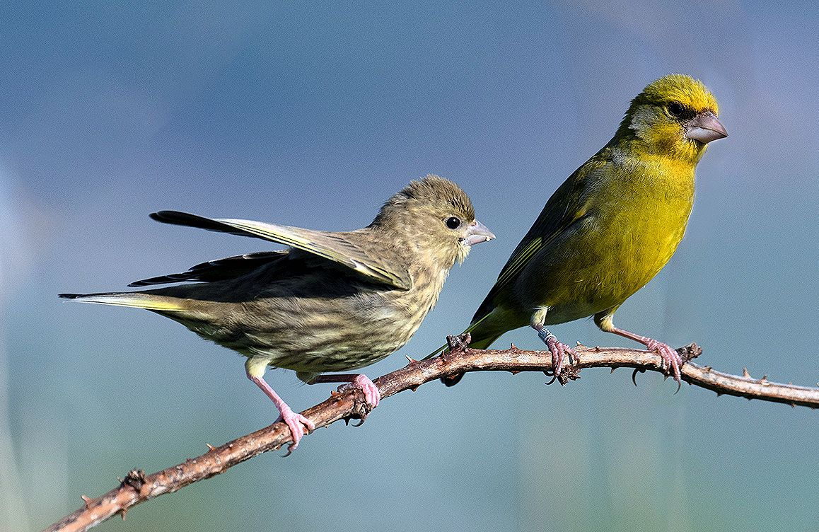
Greenfinch – adult male / begging juvenile 1st June / Photo Jo

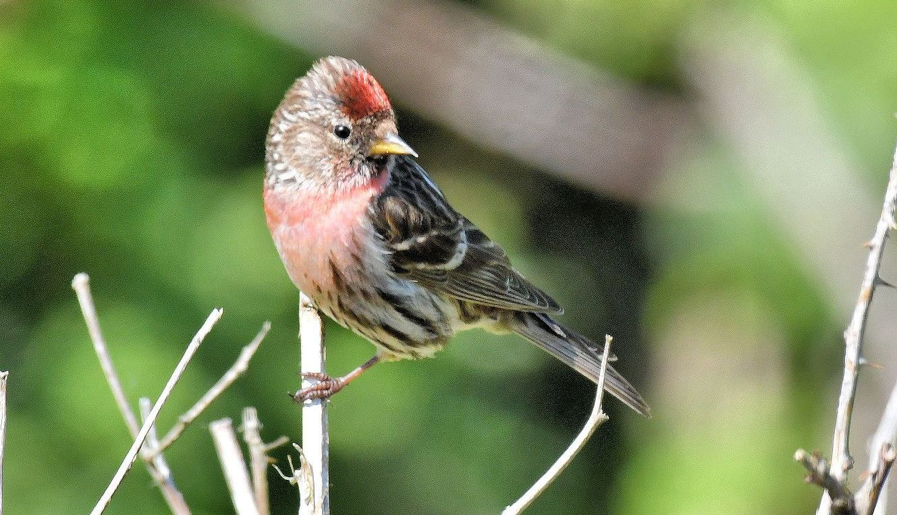
Lesser Redpoll – 14th June / photo Eddie

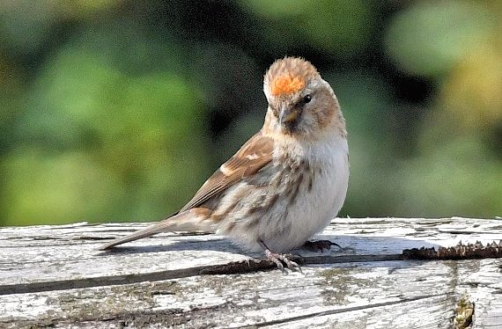
Lesser Redpoll – 17th June / Photo Eddie

Common Redpoll
One on 24th.

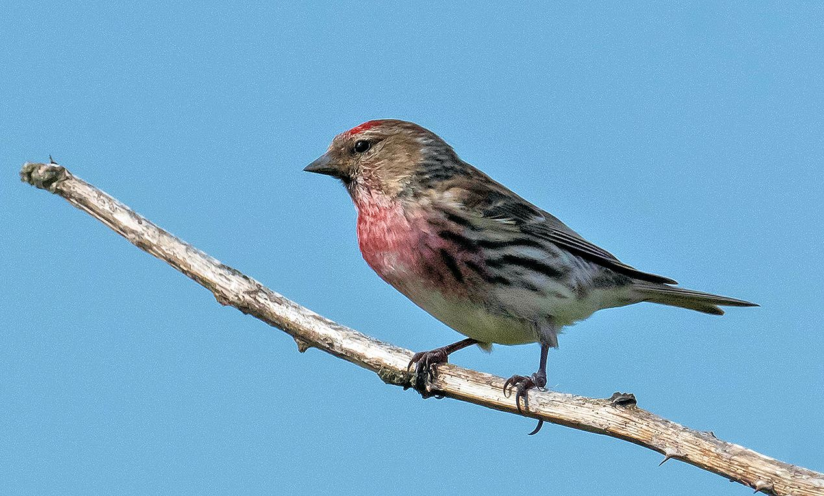
Common Redpoll – 24th June / Photo David

Common Linnet
A male was feeding a fledgling on 1st. Many fledglings were noted during the month.

More June Photos mainly from the Airbase...
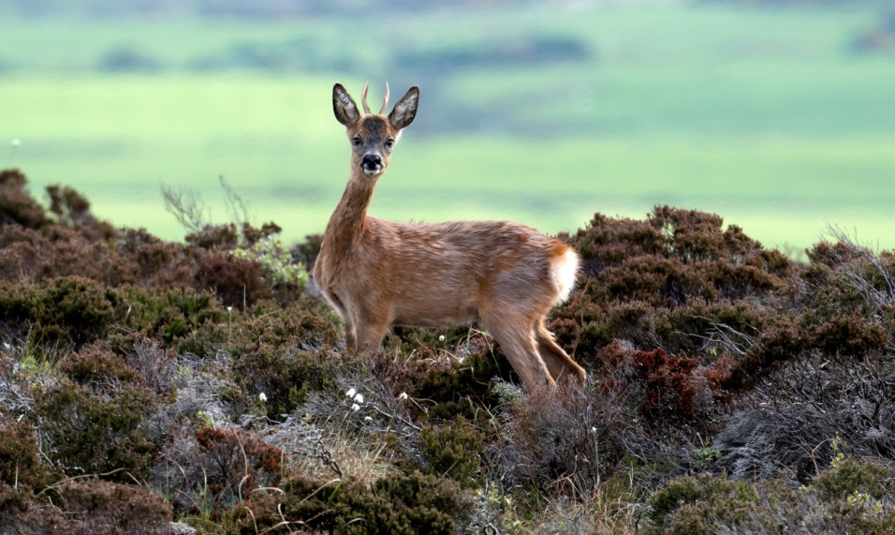
Roe Deer – 1st June / Photo David

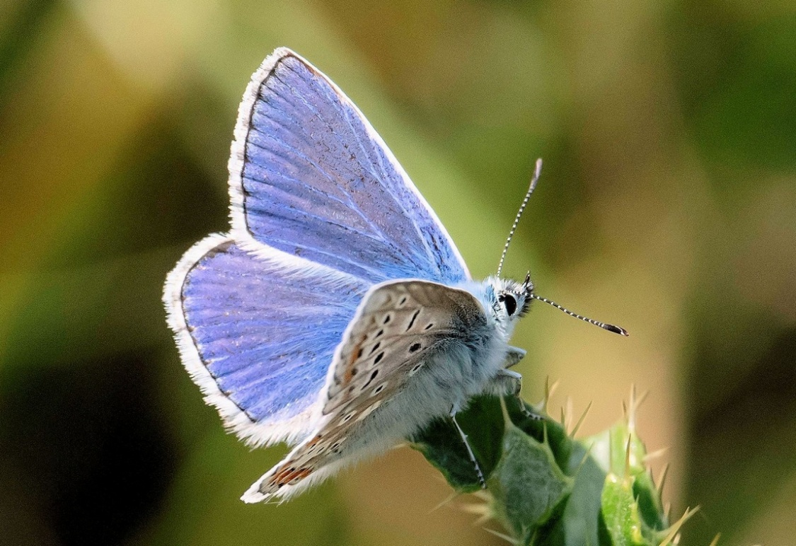
Common Blue – 14th June / photo Jo
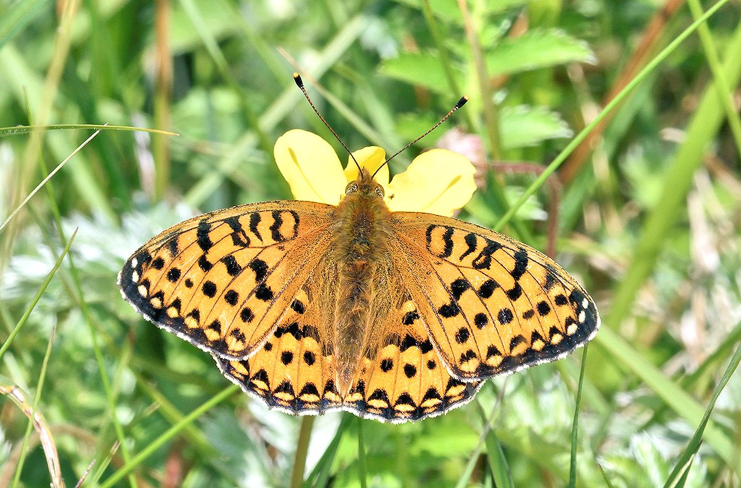
Dark-green Fritillary – 24th June / photo Jo

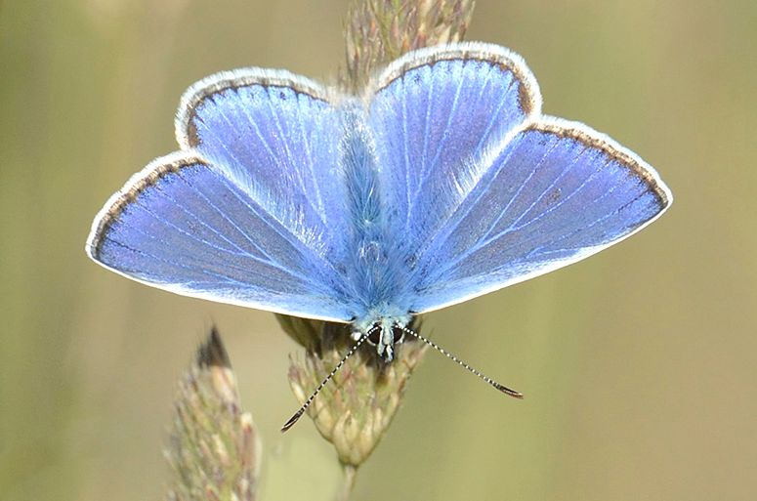

Common Blue – 24th June / photo Jo

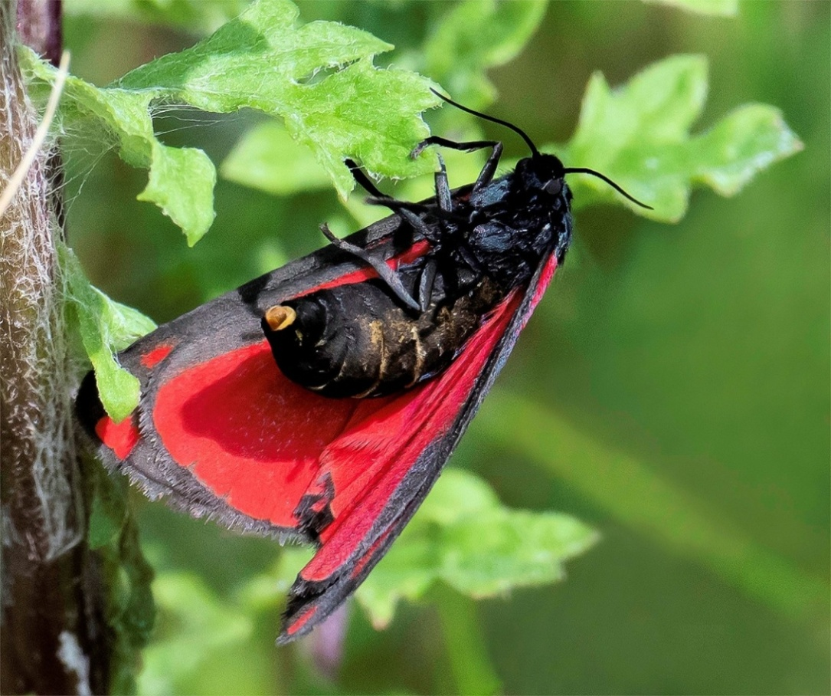
Cinnabar Moth – laying eggs on Ragwort 14th June / Photo David
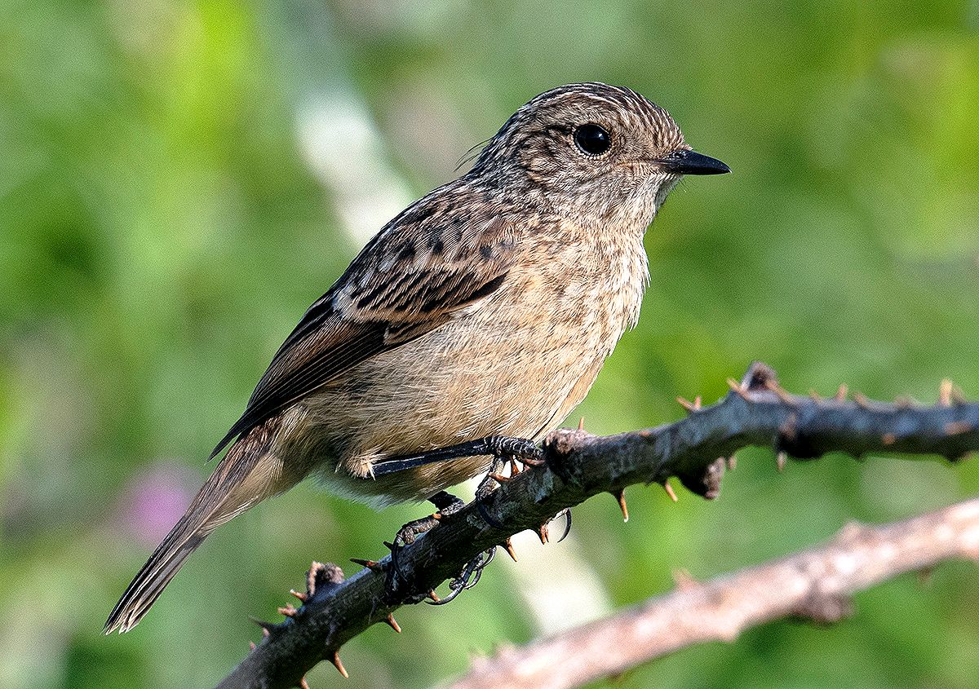
Stonechat – juvenile 1st June / Photo Jo
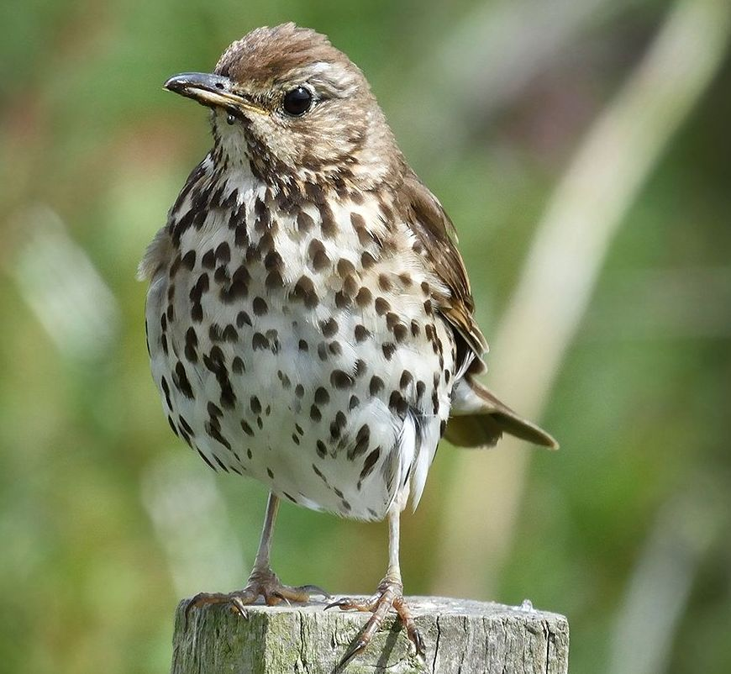
Song Thrush – 14th June / Photo Jo
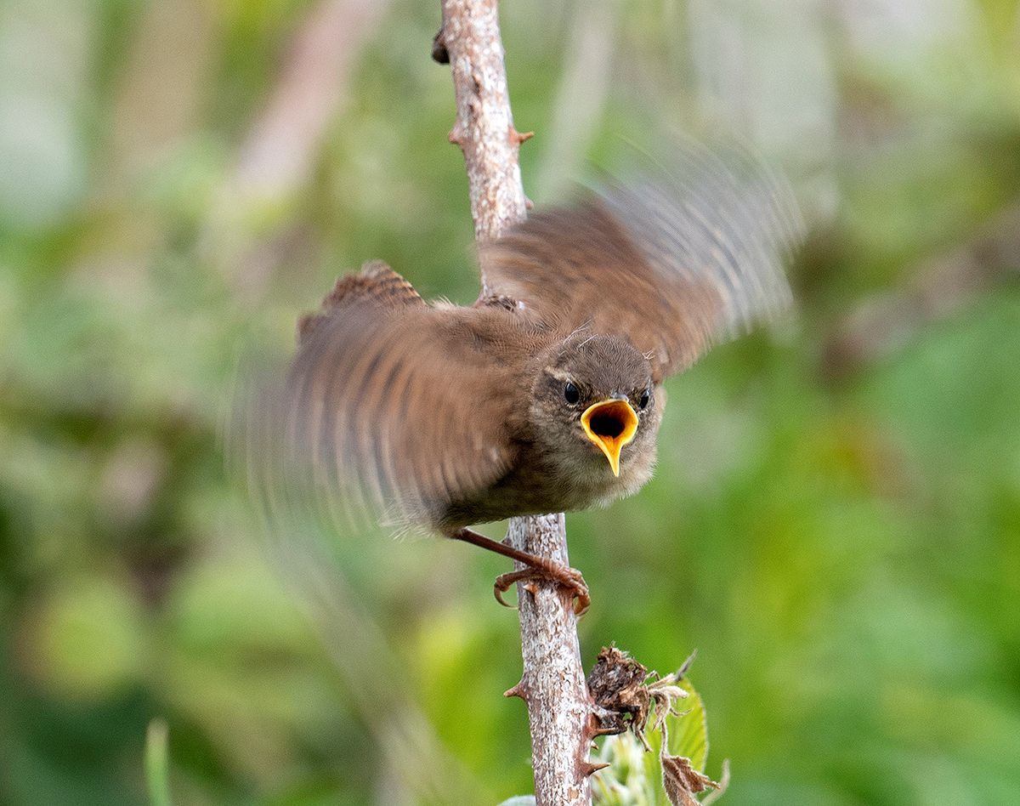
Wren – hungry fledgling 14th June / Photo Jo
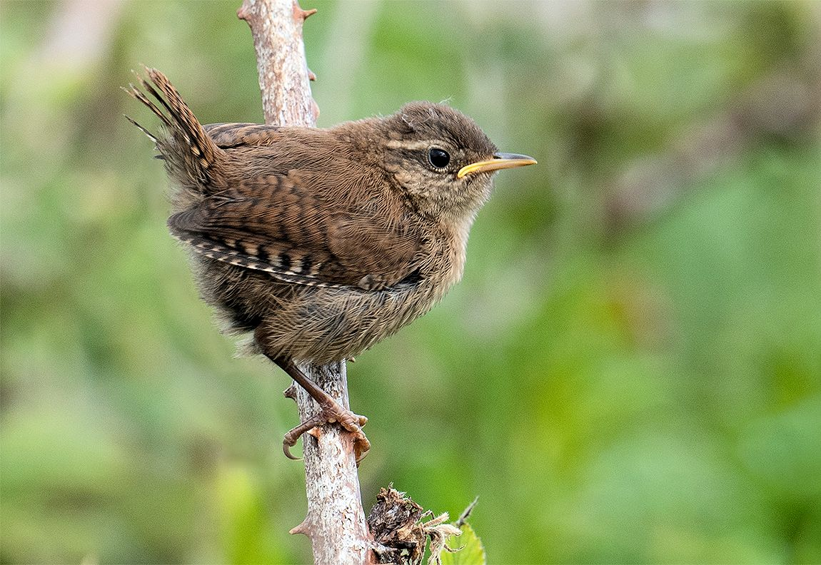
Wren – fledgling 14th June / Photo Jo

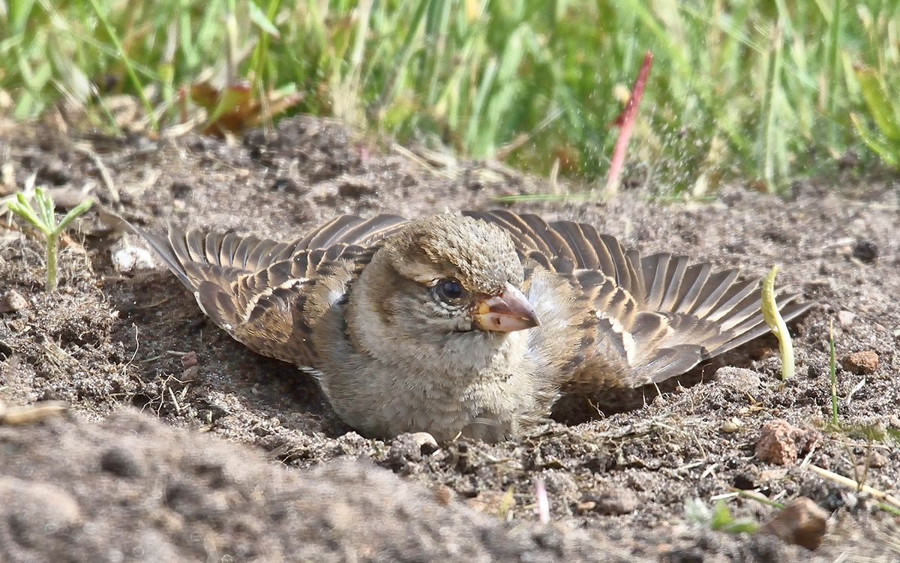
House Sparrow – having dust bath 14th June / photo Jo
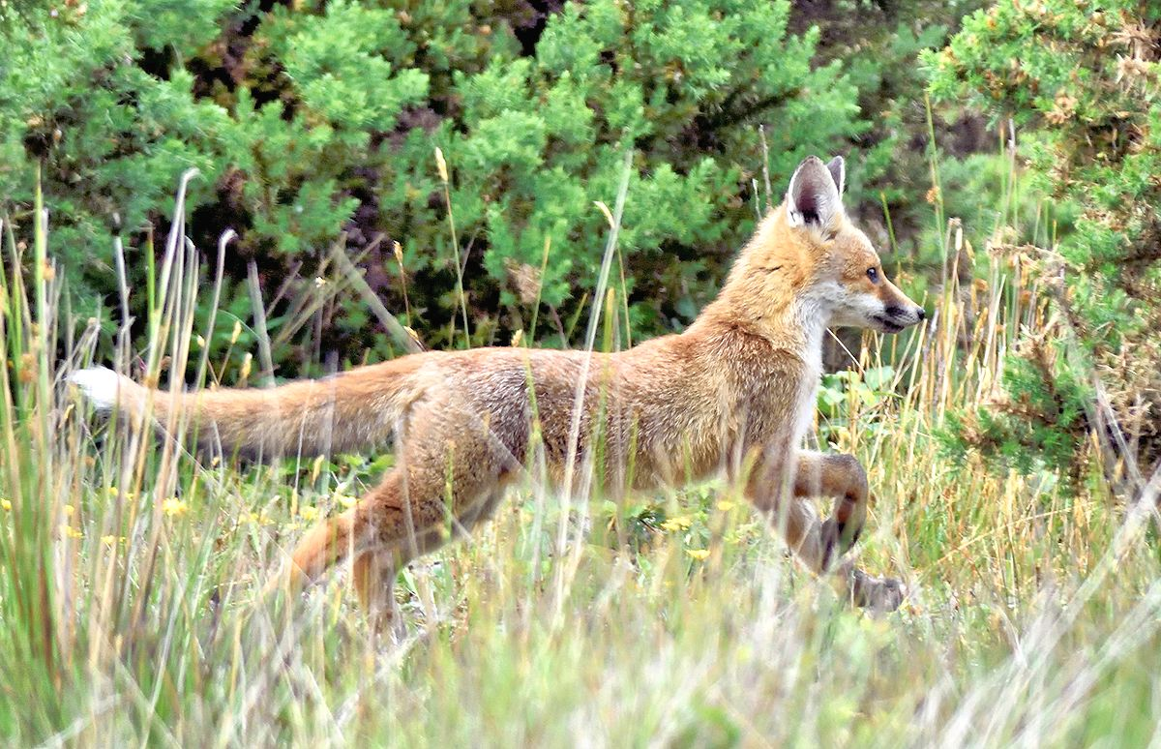
Fox-trot – cub 24th June / Photo Jo
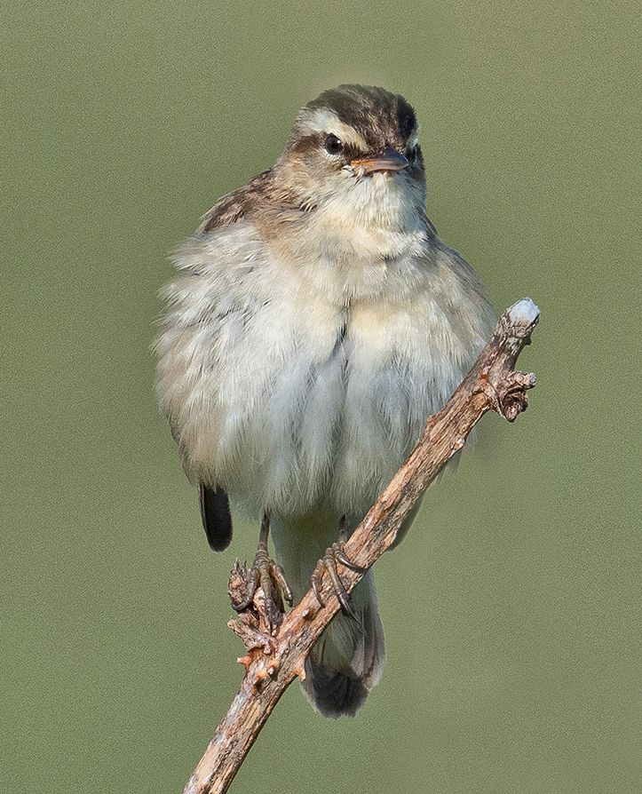
Sedge Warbler – 15th June / Photo Jo

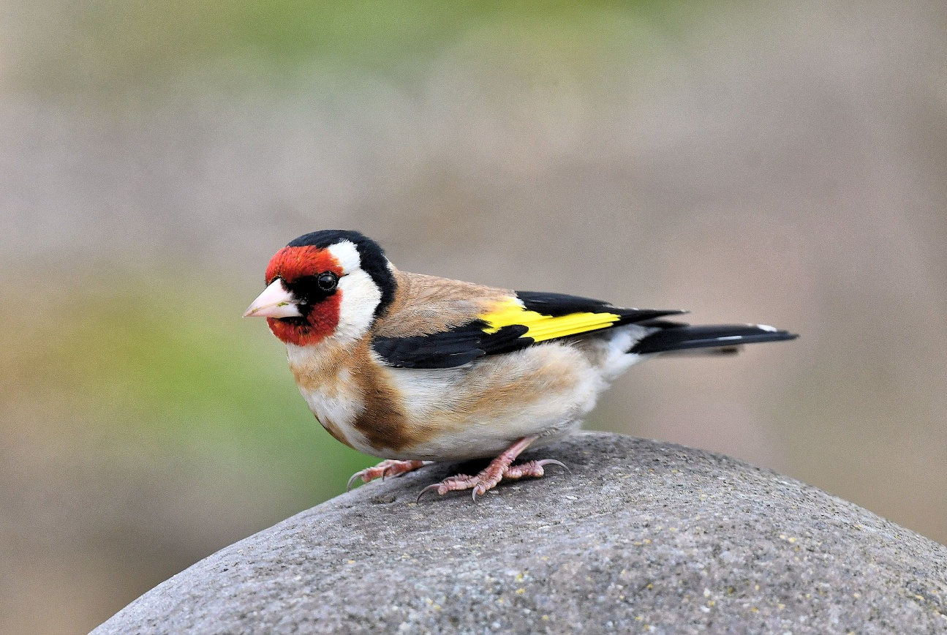
Goldfinch – MSBO 28th June / Photo Eddie

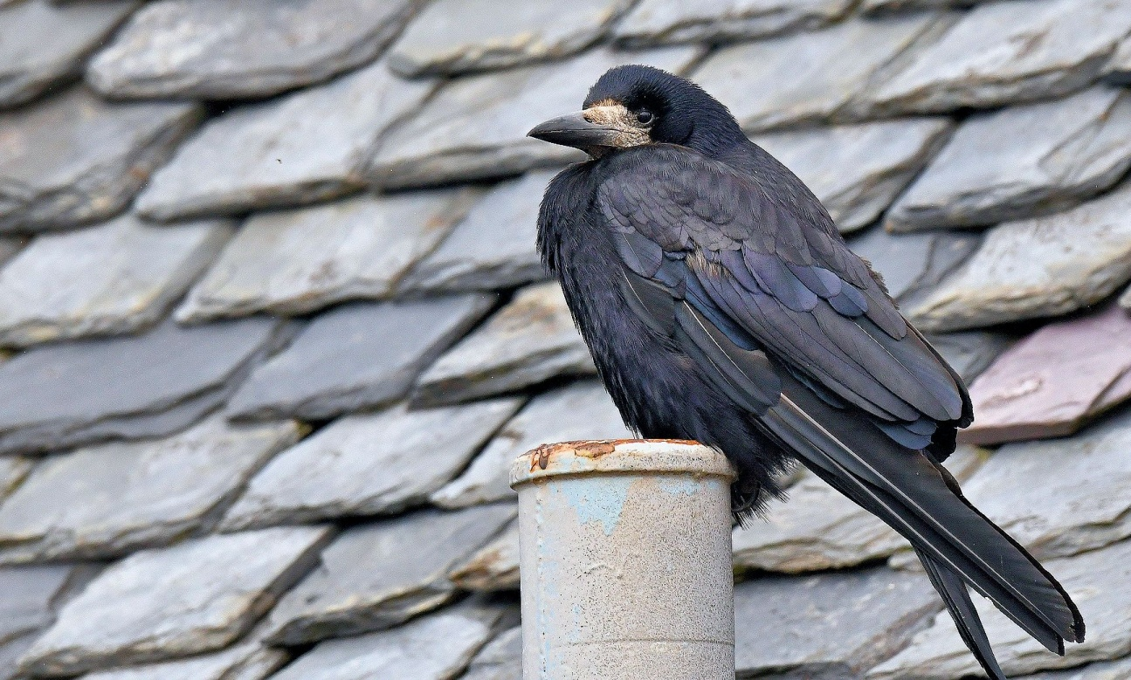
Rook – adult Campbeltown 30th June / Photo Eddie
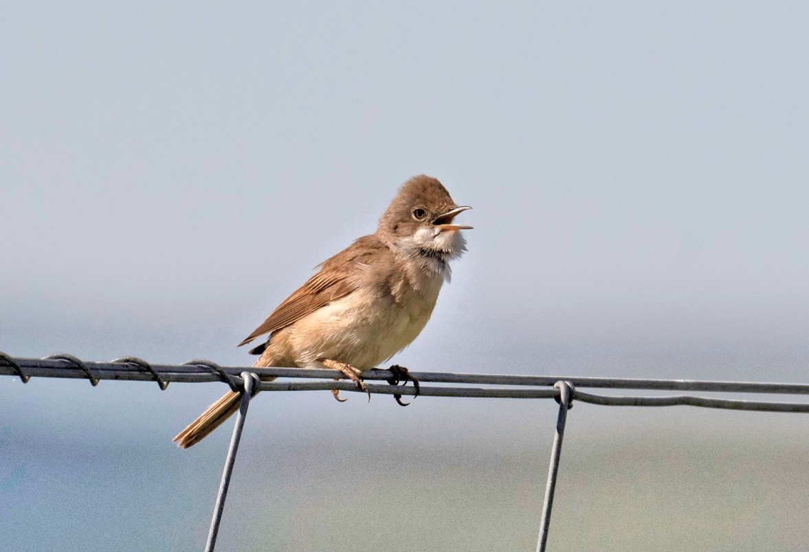
Common Whitethroat – 24th June / Photo David

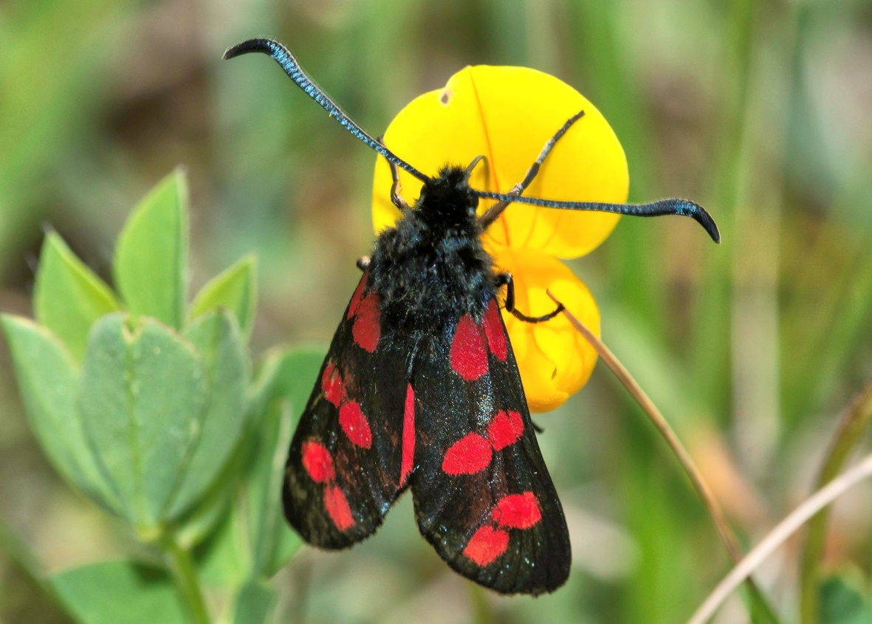
Six-spot Burnet Moth – 24th June / Photo David

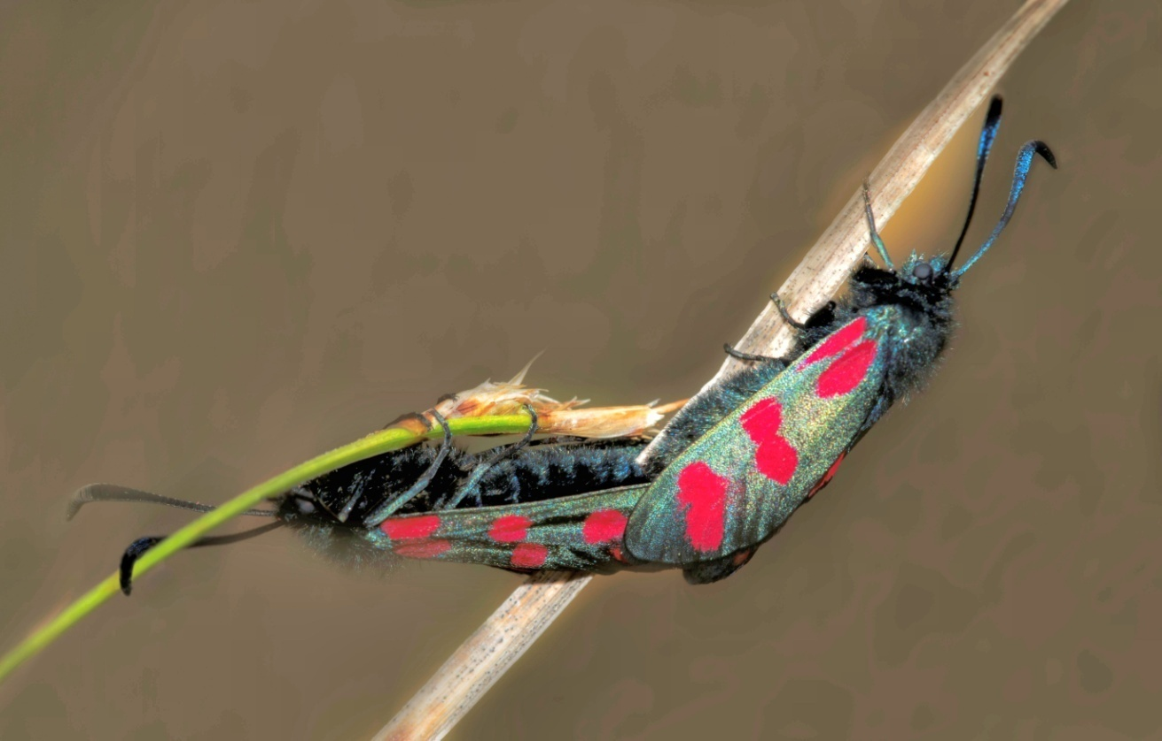
Six-spot Burnet Moths – mating 24th June / Photo David

Greater Butterfly-orchid in South Kintyre

By: Jo Goudie

The Greater butterfly-orchid is a medium height orchid of hay meadows, grasslands and ancient woodlands. It has whitish-green flowers that have spreading petals and sepals - a bit like the wings of a butterfly.
One example of this beautiful orchid was found on the MACC Airfield 25th June 2020.
Photographs were sent off for confirmation to Dave Batty of the Botanical Society of Britain and Ireland as we were unsure if it was a Greater or Lesser Butterfly-orchid.
The difference is down to the pollinae in the hood. In the Lesser, they run parallel to each other, but in the Greater they are angled into one another. The flowers produce a strong scent at night, attracting night-flying moths that pollinate it.

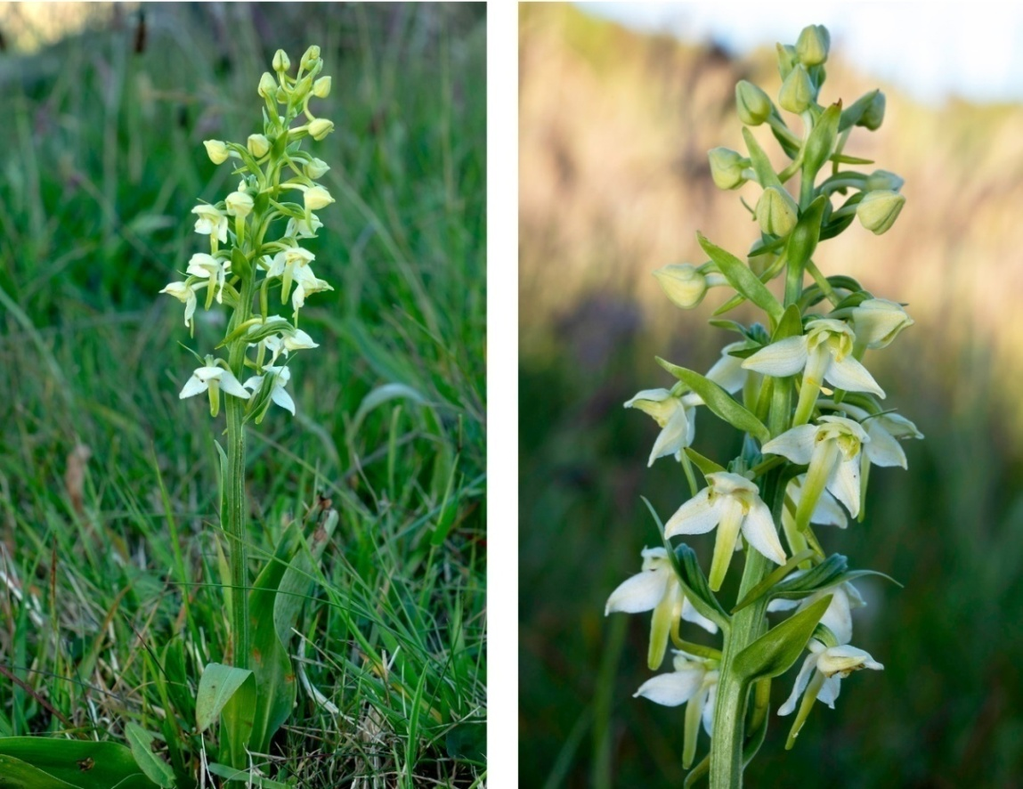

25th June / Photos David J Millward

Our photographs showed our example to be a Greater Butterfly-orchid which grows throughout Europe but is scarce in southern regions. This species has suffered declines in the UK. In the lowlands it has been lost through drainage, woodland disturbance and agricultural intensification, while upland populations have been lost to intensive grazing. The plant is now classified as Near Threatened and is uncommon in the UK.

MSBO aphorism / the Palias De Danse and a Falcons bells...
By: Eddie Maguire

‘Time spent in reconnaissance is seldom wasted’
A visitor to the Obs last month was none other than well-known Scottish birder Clive M^{c}Kay (aye, and we did adhere to social distancing). It turns out that the MSBO aphorism is Clive’s all-time favourite saying. The saying appeared in the publication ‘As the Falcon Her Bells’ by Phillip Glasier 1963 (see original plate below).
This, almost certainly, suggests a strong military link (WW2?).
As a teenager, I saw it framed on the wall of a Glasgow ballroom, the Palias de Danse in Dennistoun (where I was born). Later, in RAF service, I came to the conclusion that someone in management at ‘The Palias’ must have been in the services and possessed a wonderful sense of humour!
The Dennistoun Palias closed in 1962, much to the indignation of many Glasgow teenagers (including myself!).
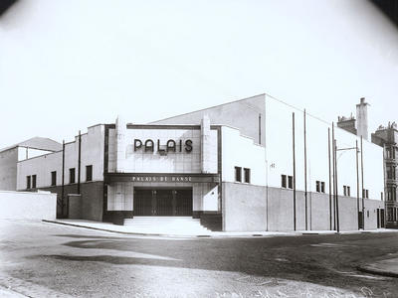
Roselea Drive / Dennistoun and the PALIAS DE DANSE
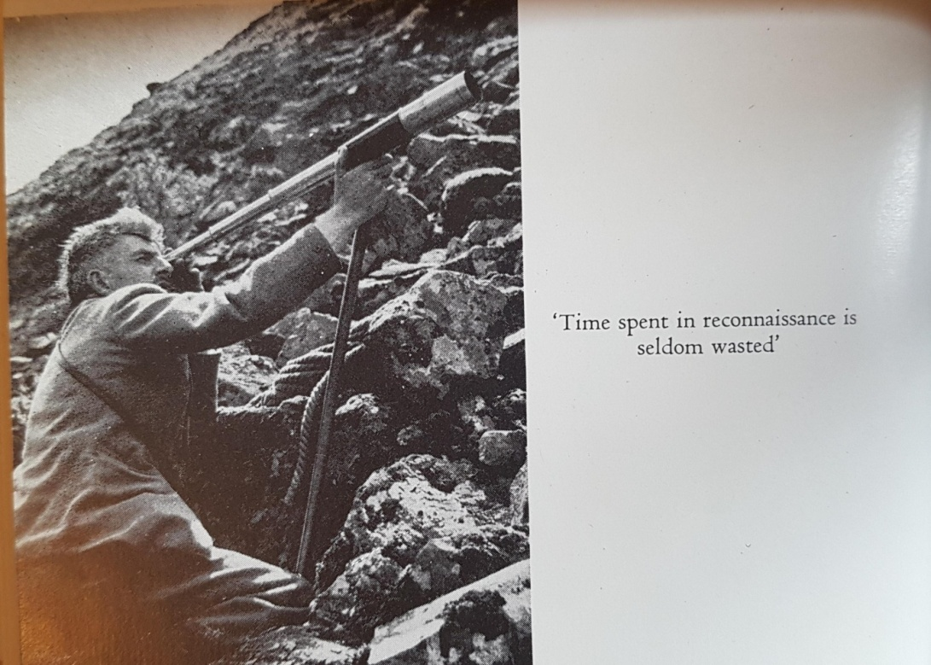
Original plate from ‘As the Falcon Her Bells’ (Photo / Clive M^{c}Kay)
I think the guy peering through what looks like a 3-draw Broadhurst-Clarkston must be Phillip Glasier. Anyone, anywhere near a Peregrine Falcon eyrie these days, bereft of a Schedule 1 Licence and especially with a professional-looking climbing rope to hand (like the one in the photo above) would surely be liable to prosecution.

Many thanks to Clive for the photo of the original plate.

